

**Game User Manual**

**Table of Contents**

**Story**

One day, Peter wants to head to the finish line within a minimal time, as his dream is to become a pro car racer. He used his large savings to buy a racing track, and he practiced in it constantly.

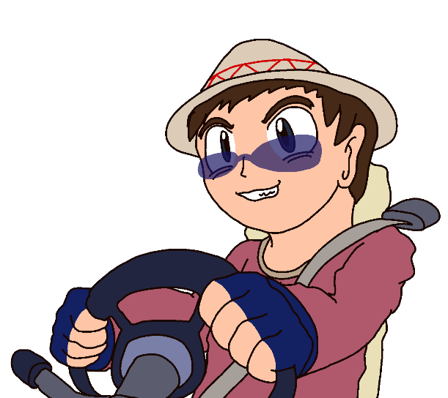**Character**

He is called Peter who dreamed to be a pro car racer. He has a huge money to buy racing training grounds and cars, so that he can train more and become a professional racing driver. He loves to wear a Mexican hat and eat tacos. Also, he likes to collect vehicles, and he also bought a lot of vehicles to enter the training ground he bought.

**How to play**

1. At the beginning, in the Main Menu, we can choose the vehicle we like.
2. We have three scenes and we need to pass the level. If you pass the three scenes, you can pass the game.
3. We will have a time limit, and we cannot reach the end in more than four minutes.
4. The difficulty of the map will become more and more difficult, players need to keep the fastest possible speed to complete the game.
5. There will be many turning positions on the map, so players try not to drive outside.
6. We have four vehicles for us to choose:

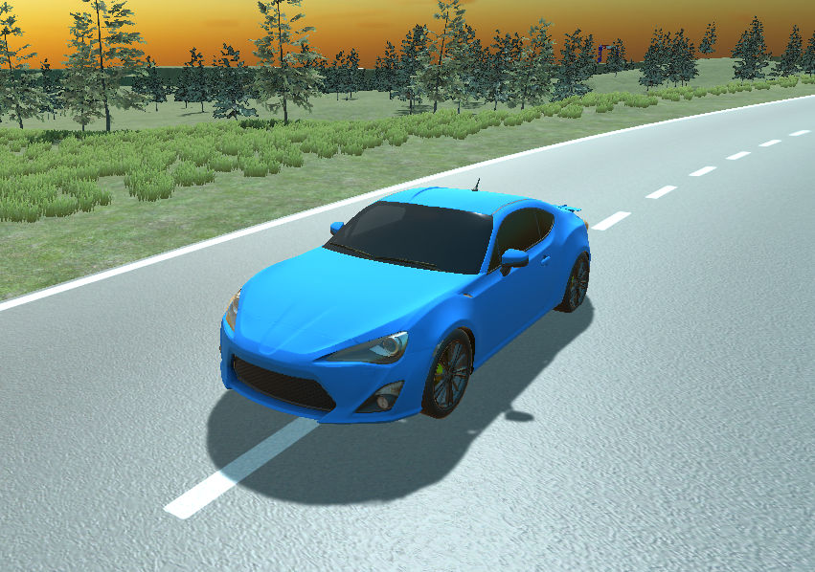

He is an all-blue AR-8 model vehicle with comprehensive performance

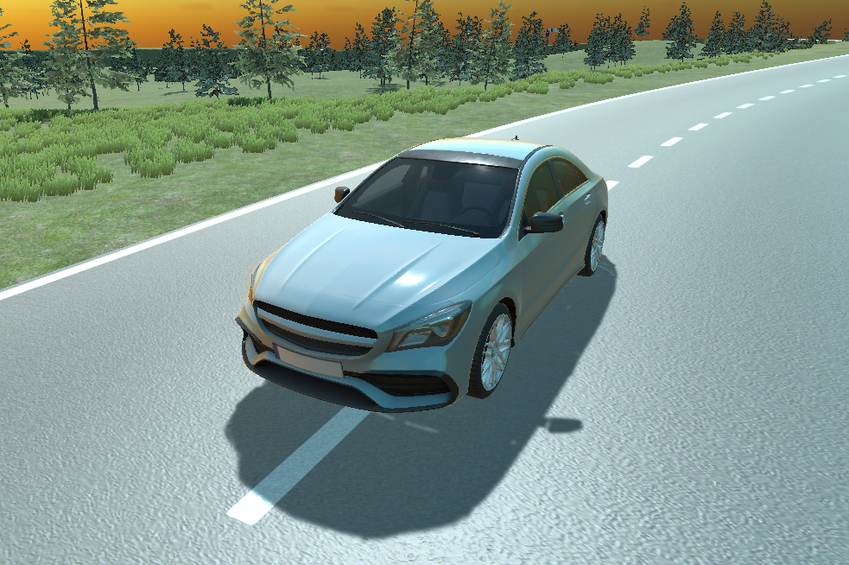

He is a better car when turning, the color is all silver

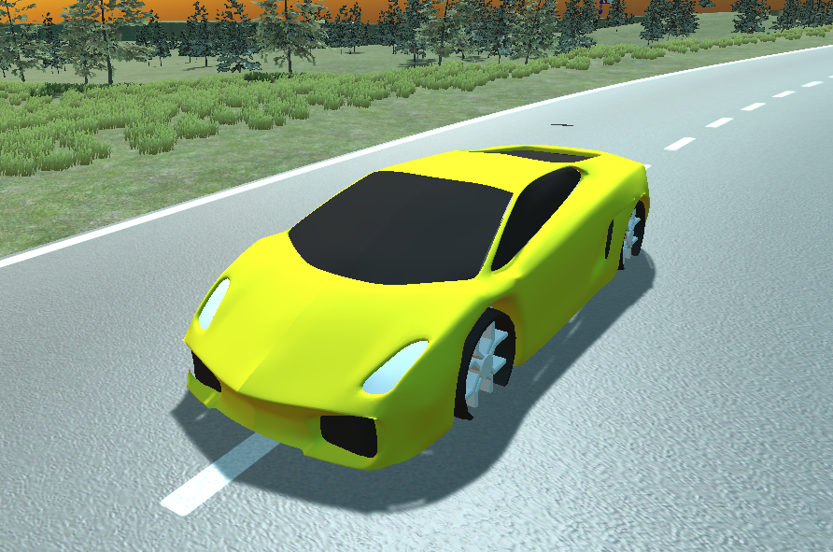

He is an all-yellow Lamborghini and he pays great attention to speed

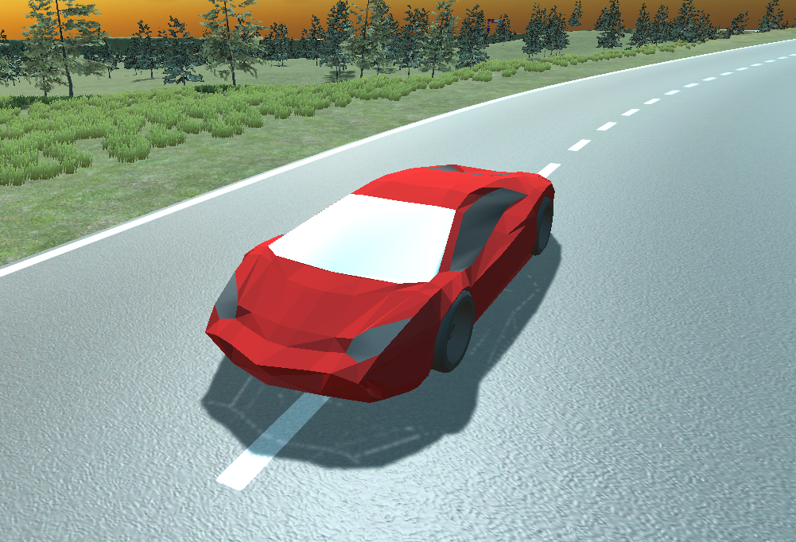

He is an all-red Lamborghini with very high performance in terms of speed.



**Game Control:**

control method is to use your fingers to control

* turn left → Overlapping the thumbs finger can make the vehicle turn left
* turn right → Overlapping middle can make the vehicle turn right
* brake → Overlapping the index finger can make the vehicle brake

**Game Rules:**

* 1. Players need to complete the game within the four-minute time limit, otherwise the game will fail
  2. Players cannot drive outside the fence
  3. Slowly challenge yourself to the fastest speed, let yourself reach the end in the fastest time
  4. Players can use all vehicles to reach the end of the challenge

**Game Design:**

1. **Time**

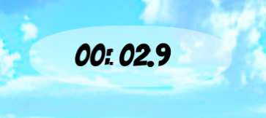

We can see the above time to show the player their time for each game, and the time will continue to the next level, and the player needs to reach the level within four minutes.

1. **Mini map**

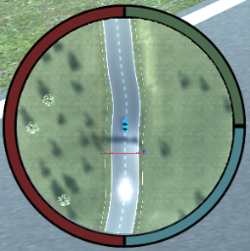

We can see the small map in the lower right corner to show the player their location and nearby roads, so that the player can know the information on the map.

1. **Car Speedometer**

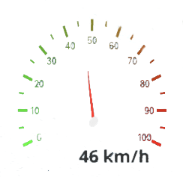

We show a speedometer to the player, so that the player can immediately clear and see what their current speed is, so that the player can know the need to slow down when turning, and so on.